**Senior Citizens use of Social Media in Waterloo: A Qualitative Study**

Justin A. Example

Department of Psychology, Wilfrid Laurier University

PS398: Qualitative Methods in Psychology

Dr. Livia Dittmer

November 15, 2030

# Introduction

This document should help you format your essays. It follows the writing conventions of the American Psychological Association (APA) manual of style 7th Edition. You can edit this document as you explore it. While I demonstrate the APA writing conventions in this guide, I will also share some tips and tricks with word processors.

I have created it in Windows 10 using the Microsoft Word desktop application but have tested it in Pages on MacOS and Google Docs. It works in them, but with a few noted exceptions.

# Word Processors: Tips and Tricks

That was a heading 1. Word processors have a lot of features that help make writing easier. The more students know about the features built into word processors, the easier it is to write an essays or thesis. Learning to use a word processor is a life-long skill to have. I learned to use it through a librarian when I was a grad student and I also learned cool techniques by working with a blind scholar.

## Microsoft Word for Windows and Mac

That was a heading 2. Microsoft Word is available as a desktop application on both Windows and Mac and as a web app. I’ve found the desktop app to be more powerful than the web app versions. I’ve also found Mac’s Word has some bugs with VoiceOver. Mac’s Pages may be better.

## Pages for MacOS

Pages is the word processor that comes with MacOS. It provides lots of features, although Microsoft Word may have more. I’ve noticed some bugs with Voiceover and Pages (12.2.1) on MacOS (13.1). If you use Voiceover, feel free to contact me.

## Google Docs

Google Docs is a new word processor that is popular. I haven’t used it much for academic writing. I think it provides tools to do about 60% of the styles needed for APA (see next section). The last 40% will have to be done manually.

# Styles

Back to a heading 1! Do you want to make writing a whole lot easier? If so, it’s worth learning about the styles feature of your word processor. A style is a set of attributes about text, such as font size, bolding, line spacing, indent, etc. We can create a style with all this font information then give the style a name, like “Paragraph”. We can easily apply this Paragraph style to text to ensure consistency. This means we can create styles that follow the American Psychological Association requirements and easily apply that style to text in our essay.

Styles are a common feature of many word processors, although each may have differences. I’ve tried to describe how to use styles in common word processors used by students. If I missed yours, please email me, [mweiler@wlu.ca](mailto:mweiler@wlu.ca) so I can update this guide.

This document has a series of styles that match the APA requirements for a basic student essay. For example, I created a style for generic paragraphs, heading levels 1 through 5, and reference items in the reference list. You can use this document by deleting all of the contents, saving it, and then writing your essay in it.

## Microsoft Word: Styles Gallery

To give your text proper style, put the cursor on the text you want to modify, then select the style from the Style Gallery.

### Using the Mouse to Select a Style

That was a heading 3. You can use the mouse to go to Home Tab which contains the Styles group where you will find the Styles Table. This table contains buttons of the available styles that can be applied to the text in your essay.

Figure 1

The Home Tab in Word for Windows contains the Style Gallery

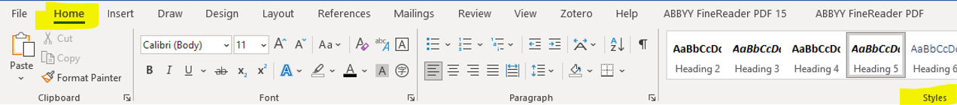

Figure 2

The Styles Gallery in Word for Windows (desktop app)

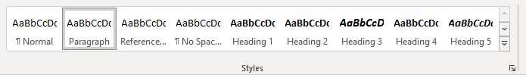



Figure 3 Styles Table

The Style Tables displays a grid of style buttons

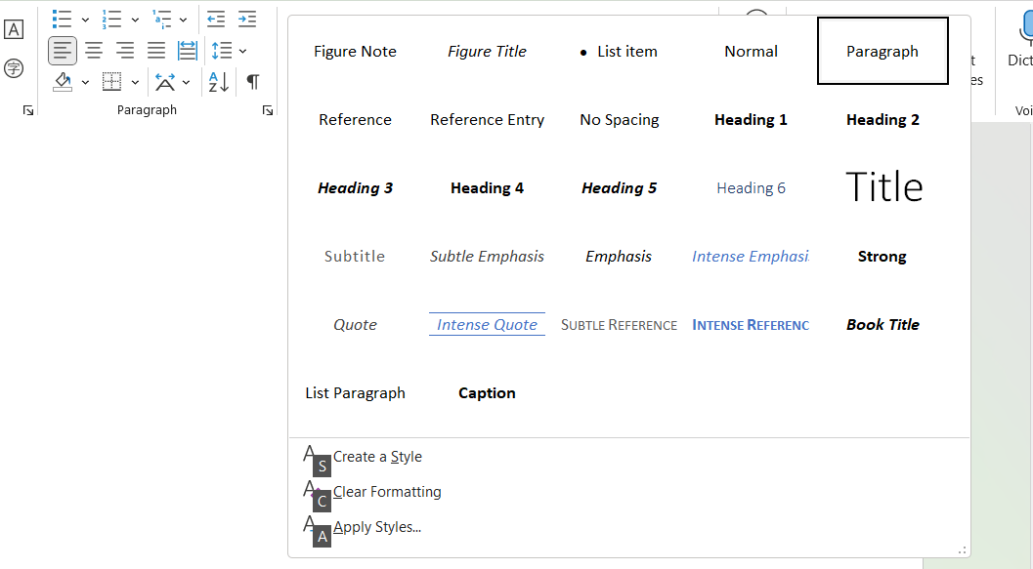

### Using the Keyboard to Select a Style

If you are using Microsoft Word’s desktop app, you can use the keyboard to issue access key commands to move the keyboard focus the style you want. Press and release the ALT key then press and release the H key, then the L key. This moves the keyboard focus to the Home Tab, Styles Group, and into the Styles Table. These are called access keys and can be blazing fast. Did you know it’s probably possible to use your computer without touching the mouse or trackpad!

Once you press and release the ALT key, Word displays letter icons on the interface to prompt sighted users (see Figure 4). You can then use the arrow keys to move around the style options.

Figure 4

The access keys appear on the user interface after pressing the ALT key

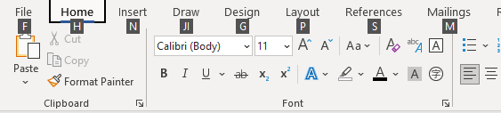

## Pages on MacOS: Formatter, Style Button Group

In Pages for MacOS, there is a Formatter group that contains a button “choose a style to apply to a paragraph”. Press SPACE to expand a table of Paragraph styles.

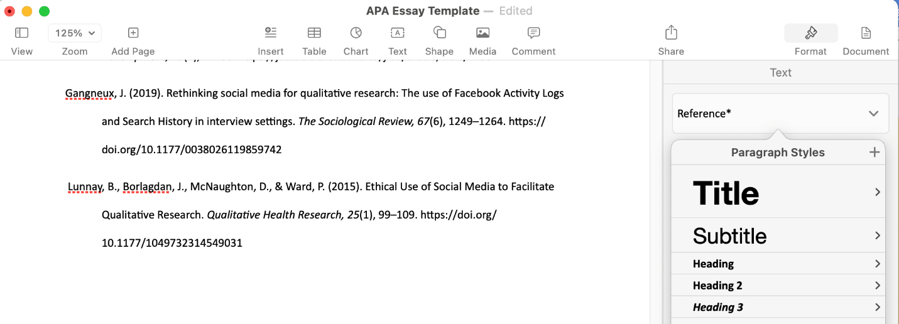It contains the custom ones I’ve created in this document:



* Paragraph
* Reference
* Heading 1
* Heading 2
* Heading 3
* Heading 4
* Heading 5

## Google Docs: Styles Popup List

Google Docs provides users with a way to apply some of the styles in this templated. The styles feature is in the main toolbar (see Figure 5) or in the Format menu (Alt + o) at the Paragraph styles menu option.

Figure 5

The styles popup list in Google Docs

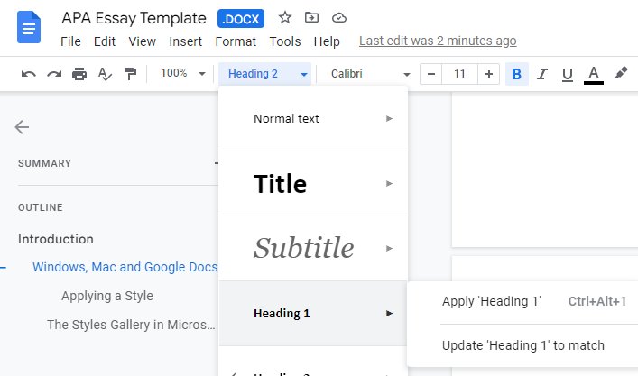

**The Styles Popup menu in Google Docs lists many styles available in the APA Essay Template.** However, Google Docs does not show all the styles I’ve created (e.g., paragraph, reference entry). If you use Google Docs, you will have to format sections manually

# Page Numbers

According to the APA manual of style, for student essays, page numbers are to appear on all pages. The numbering starts with 1 and they are in the top right of the page header. The page header is a region at the top of each page.

Figure 6

The page header contains the page number

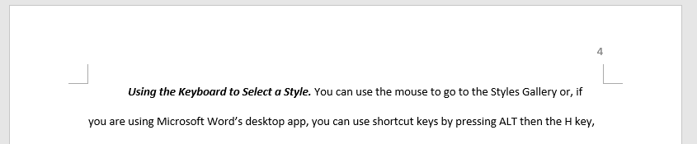

## Microsoft Word: Adding Page Numbers

## Google Docs: Adding Page Numbers

Figure 7

Google Doc’s Format menu and Page numbers menu item

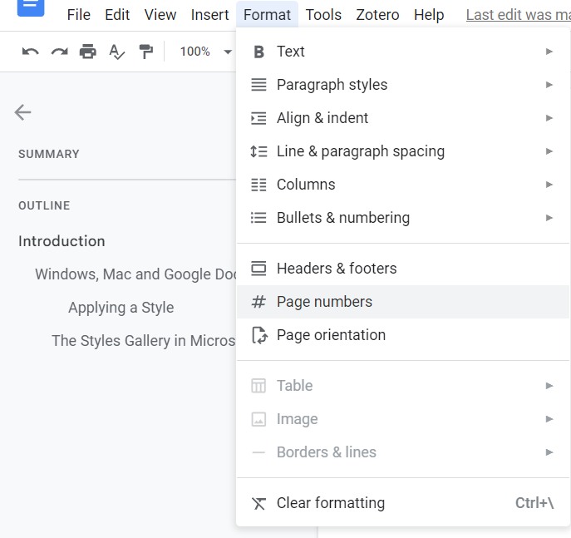

## MacOS and Pages: Adding Page Numbers

You can add a page number by going to the Page header (see Figure X).

Figure 8

Position the cursor in the Page Header

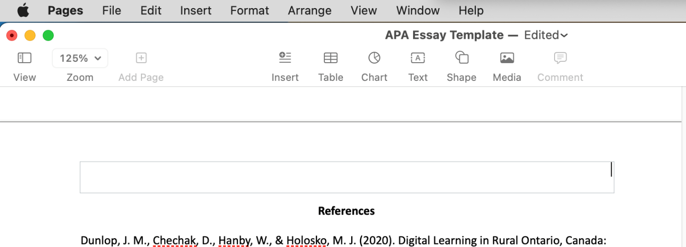Then open the Insert menu and select page number. Make sure you align the page number to the right.



Figure 9

Adding page numbers to the header

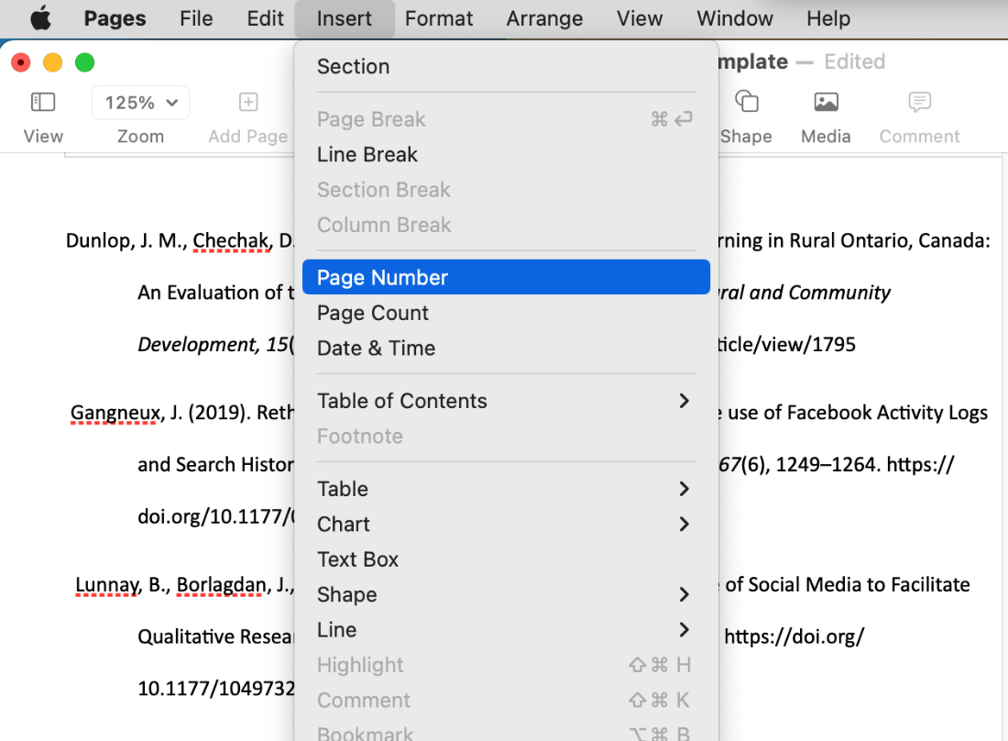

# References

Dunlop, J. M., Chechak, D., Hanby, W., & Holosko, M. J. (2020). Digital Learning in Rural Ontario, Canada: An Evaluation of the Computer for Seniors Program. *Journal of Rural and Community Development, 15*(4), 24–38. https://journals.brandonu.ca/jrcd/article/view/1795

Gangneux, J. (2019). Rethinking social media for qualitative research: The use of Facebook Activity Logs and Search History in interview settings. *The Sociological Review, 67*(6), 1249–1264. https://doi.org/10.1177/0038026119859742

Lunnay, B., Borlagdan, J., McNaughton, D., & Ward, P. (2015). Ethical Use of Social Media to Facilitate Qualitative Research. *Qualitative Health Research, 25*(1), 99–109. https://doi.org/10.1177/1049732314549031